There are 4 components you are trying to install:
- Cuda
- Cudnn
- tensorflow
- keras
they are not always synchronized, as of today tensorflow supports cuda 9.1 if you compile it yourself (like the guide you posted), the prebuilt binaries were compiled with cuda 9.0 and cudnn 7. I prefer using them so this is this is the cuda version I'm using.
this is how you can install it:
first, remove existing cuda installations:
sudo apt-get remove --purge nvidia-*
install ubuntu headers and cuda 9.0:
sudo apt-get install linux-headers-$(uname -r)
CUDA_REPO_PKG=cuda-repo-ubuntu1604_9.1.85-1_amd64.deb
wget -O /tmp/${CUDA_REPO_PKG} http://developer.download.nvidia.com/compute/cuda/repos/ubuntu1604/x86_64/${CUDA_REPO_PKG}
sudo dpkg -i /tmp/${CUDA_REPO_PKG}
sudo apt-key adv --fetch-keys http://developer.download.nvidia.com/compute/cuda/repos/ubuntu1604/x86_64/7fa2af80.pub
rm -f /tmp/${CUDA_REPO_PKG}
sudo apt-get update
sudo apt-get install -y cuda-9-0
download cuDNN v7.0.5 Library for Linux from nvidia site, navigate to downloaded folder and install it:
tar -xzvf cudnn-9.0-linux-x64-v7.tgz
sudo cp cuda/include/* /usr/local/cuda/include/
sudo cp cuda/lib64/* /usr/local/cuda/lib64/
reboot your machine and check nvidia driver works using:
nvidia-smi
the output should look like this:
+-----------------------------------------------------------------------------+
| NVIDIA-SMI 390.30 Driver Version: 390.30 |
|-------------------------------+----------------------+----------------------+
| GPU Name Persistence-M| Bus-Id Disp.A | Volatile Uncorr. ECC |
| Fan Temp Perf Pwr:Usage/Cap| Memory-Usage | GPU-Util Compute M. |
|===============================+======================+======================|
| 0 GeForce GTX 105... Off | 00000000:04:00.0 On | N/A |
| 0% 33C P8 N/A / 120W | 310MiB / 4038MiB | 0% Default |
+-------------------------------+----------------------+----------------------+

+-----------------------------------------------------------------------------+
| Processes: GPU Memory |
| GPU PID Type Process name Usage |
|=============================================================================|
| 0 1307 G /usr/lib/xorg/Xorg 141MiB |
| 0 2684 G compiz 120MiB |
| 0 4078 G ...-token= 45MiB |
+-----------------------------------------------------------------------------+
Open PyCharm:
New project--- create Virtual Env with Python 3.5.2 or 3.6
Create test.py

Click--- small arrow after the file name--- select Edit Configuration
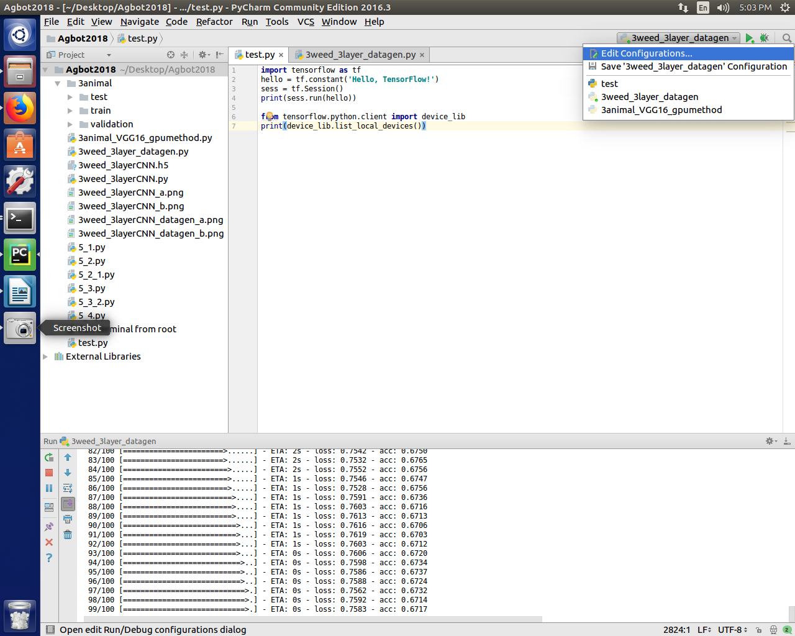

Click ‘…’ button on ‘Environment variables’:

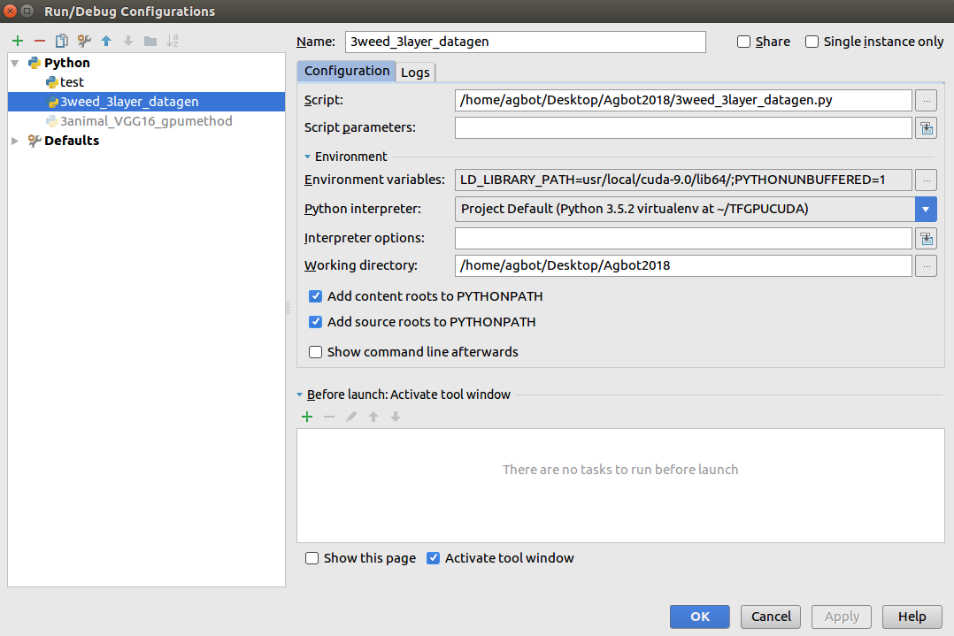

Click add (green plus)--- Under ‘Name’ paste: LD_Library_PATH
Under ‘Value’ paste: usr/local/cuda-9.0/lib64/ or usr/local/cuda-9.0/lib64/
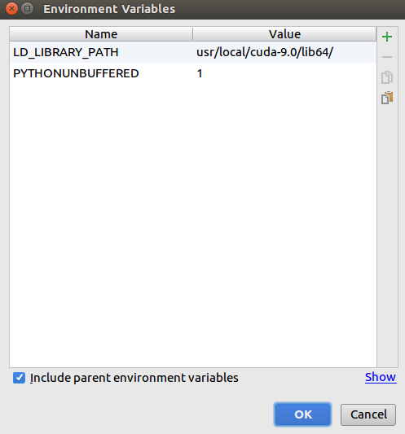

Go to Settings---Project Interprater---install tensorflow-gpu

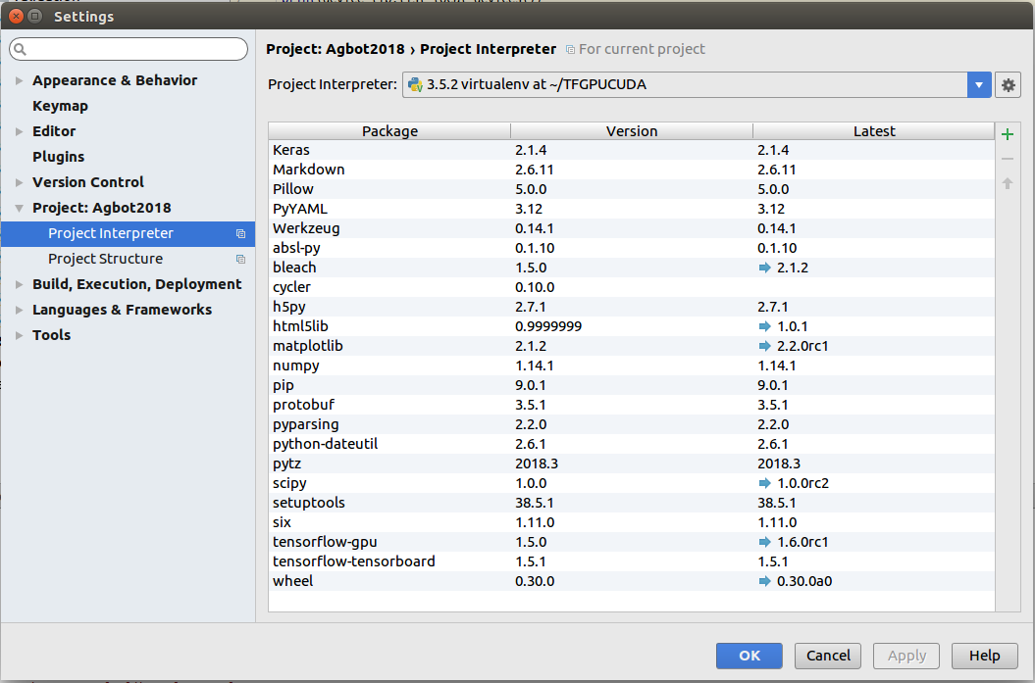
This code:

from tensorflow.python.client import device_lib
print(device_lib.list_local_devices())
Will result the following:

[name: "/device:CPU:0"
device_type: "CPU"
memory_limit: 268435456
locality {
}
incarnation: 14511791577254305993
, name: "/device:GPU:0"
device_type: "GPU"
memory_limit: 78315520
locality {
bus_id: 1
}
incarnation: 17069329026560237293
physical_device_desc: "device: 0, name: GeForce GTX 1060 6GB, pci bus id: 0000:01:00.0, compute capability: 6.1"

